SABER VS CONOCER
In Spanish, there are two verbs that express the idea “to know.” These two verbs are “saber” and “conocer.” The verb you choose depends upon the context in which it is used. These verbs are not interchangeable.
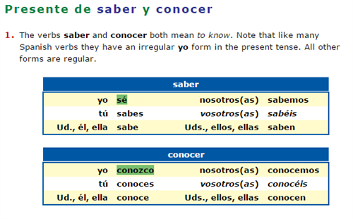
SABER
to know a fact, to know something thoroughly, to know how to do something
- To express knowledge or ignorance of a fact or information about something, use “saber.”
Juan sabe donde está María.
Juan knows where Maria is.
Yo no sé tu número de teléfono.
I don’t know your telephone number.

- If questions word are included in the sentence, use saber.

¿Sabes dónde está la biblioteca?
Do you know where the library is?
- To express knowledge or ignorance of a skill, or how to do something, use saber + infinitive.
María sabe conducir.
Maria knows how to drive.
No sé nadar muy bien.
I don’t know how to swim very well.
- To say that you know something by heart, use saber.
María sabe los verbos irregulares.
Maria knows the irregular verbs (by heart).
Ella no sabe la letra de esa canción.
She doesn’t know the words to that song.

CONOCER
to be acquainted with a person, place, or thing
- To say that one is or is not acquainted with a person, a place, or an object, use conocer.
Yo no conozco a María.
I don’t know (am not acquainted with) Maria.
Alberto y Alfredo conocen Madrid.
Alberto and Alfredo know (are acquainted with) Madrid.

- When being acquainted with people use the personal “a”:
Juan conoce a Marcos.
Juan knows Marcos personally.

ACTIVIDADES

Write the correct verb form, based upon the context of the sentence.
- I know Juan. We're good friends.
Yo a Juan. Somos muy amigos.
- I'm looking for the book. Do you know where it is?
Busco el libro. ¿ usted dónde está?
- I have to call Maria. Do you know her phone number?
Tengo que llamar a María. ¿ (tú) su número de teléfono?
- Pablo is a child. He doesn't know how to drive.
Pablo es niño. No conducir.
- Do you want to speak Spanish well? You must know (by heart) the irregular verbs. (hint: use the infinitive)
¿Quiere hablar bien el español? Es necesario los verbos irregulares.
- Ask Juan. He knows the results.
Pregunta a Juan. Él los resultados.
- The girl is very intelligent. She already knows algebra.
La chica es muy inteligente. Ya el álgebra.

- I have to leave. Do you know what time it is?
Tengo que ir. ¿ (tú) la hora?
- The man is a genius. He knows that two and two are four.
El hombre es genio. que dos más dos son cuatro.
- We are familiar with Picasso's paintings. We like them.
los cuadros de Picasso. Nos gustan.
- You and Humberto aren't familiar with Acapulco. It's your first time to Mexico.
Ud. y Humberto no bien Acapulco. Es su primera vez en México.
- She is your friend. You know she's an intelligent young lady.
Ella es una amiga suya. Ud. que es una señorita inteligente.
- They are bilingual. They know how to speak Spanish and English.
Son bilingües. hablar español e inglés.
- I live in a shack. I'm not familiar with modern music.
Vivo en una choza. No la música moderna

